Task 1 – Installation

Set up a 3-node (at least) cluster of the latest Hortonworks Data Platform via Ambari installation. You'll need to evaluate which components are actually required based on the rest of the exercise. Utilize whatever technologies you have at your disposal to do so. It is highly recommended that this is done using Amazon AWS services, but local laptop (Mac, PC, etc) are fine also if you feel comfortable using technologies such as VirtualBox.

Steps Involved in Installing the Hadoop Cluster in AWS:

1. Created VPC (Virtual Private Cloud) for static network
2. Created new security group
3. Launched EC2 :t2.Large(2CPU,8GB RAM & 40gb ) Instance with RHEL 7.5 for installing cluster
4. Completed the Pre-requisites to the instance

List of pre-requisites done:

1. SELINUX disabled in /etc/selinux/config file using vi editor
2. Iptables disabled using >chkconfig disable iptables Command

>/etc/init.d/iptables stop

1. NTPD service started using >service ntpd start >chkconfig ntpd on
2. Registered the hostname of the master in /etc.sysconfig/network file using vi editor

1. Downloaded Packages required for hadoop

List of Downloaded packages:

1. http daemon using >yum –y install httpd and started the service using >Start httpd made the service default on while restarting the instance using >chkconfig httpd on
2. Installed java using >yum –y install jdk-1.7.0-openjdk
3. downloaded ambari-server repo file to /var/www/html/
4. Confirmed the repository by checking repolist> yum repolist

>wget -nv http://public-repo-1.hortonworks.com/ambari/centos7/2.x/updates/2.6.0.0/ambari.repo -O /etc/yum.repos.d/ambari.repo

1. Installed ambari-server bits using >yum install –y ambari-server which will also install ambari-postgres server
2. Used the command >ambari-server setup for setting the java paths
3. Started the ambari-server using > start ambari-server
4. Used ambari webui to deploy the remaining datanodes :13.232.83.21:8080
5. Launched 3 instances with the same configuration and the same memory
6. Associated the ips to the new launched instances from VPC
7. Updated the host names of all the instances to /etc/hosts file using vi editor in all the instances
8. Installed the HDP 2.6.3.0 usnig public repo
9. Provided the ssh key information

Below are the screenshots taken while installing the cluster ,Please check

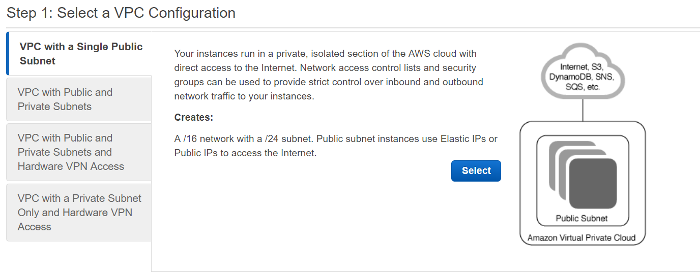

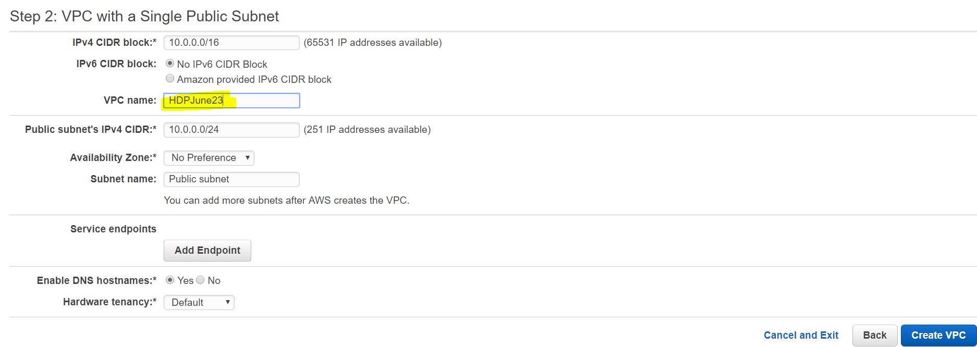

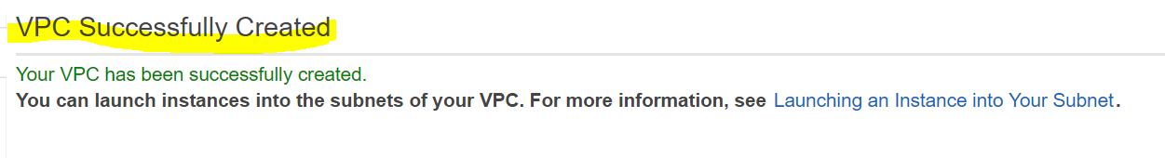

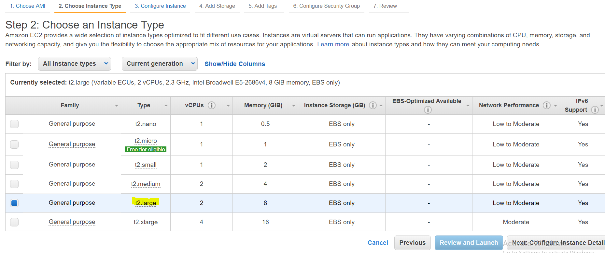

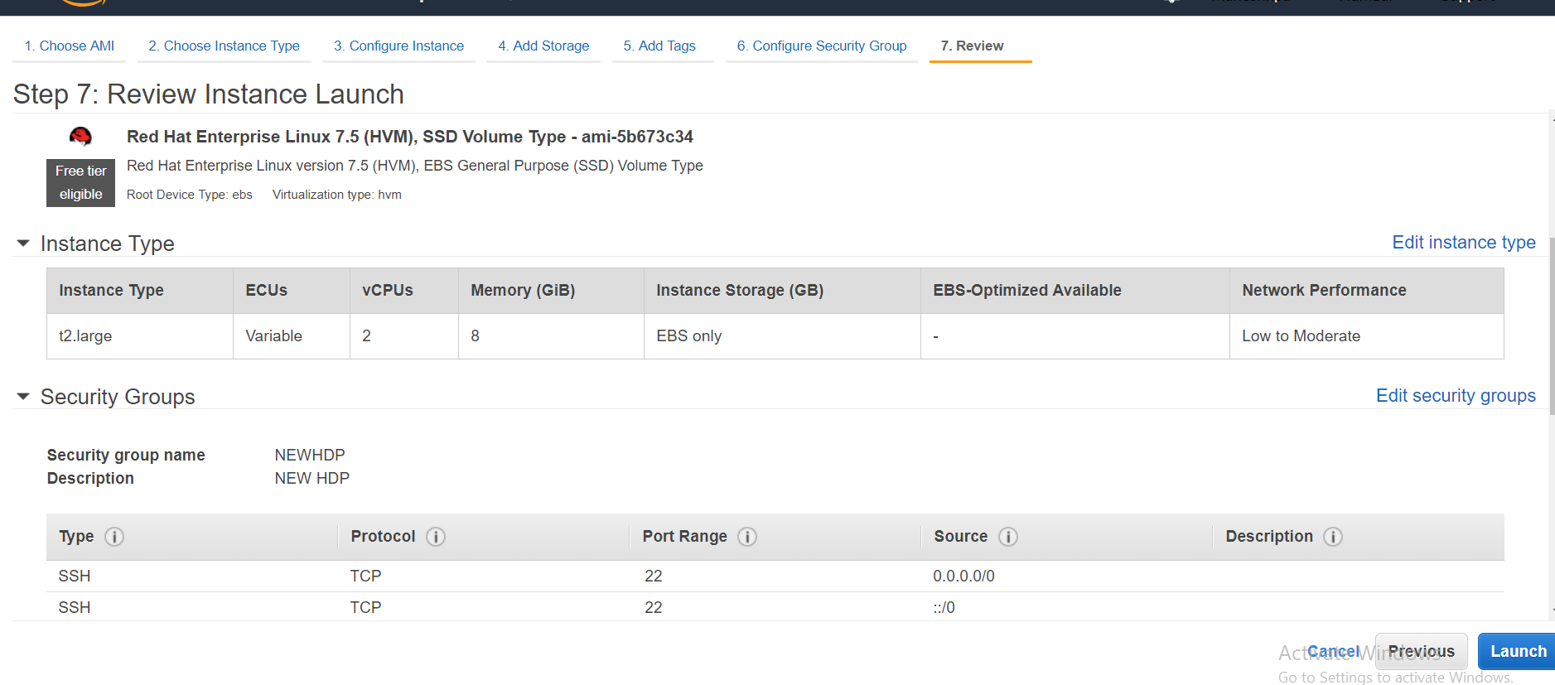

/etc/sysconfig/netwrok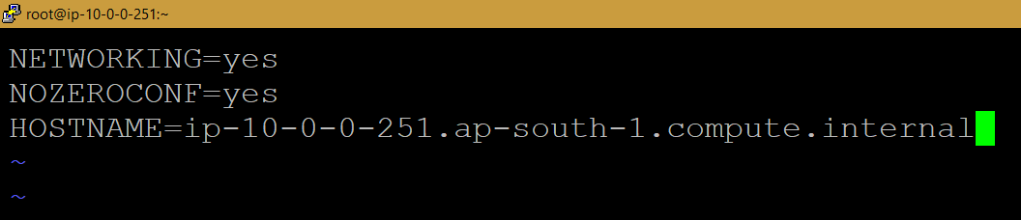

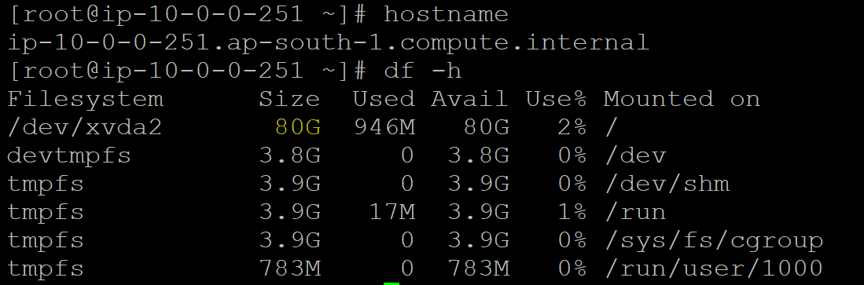

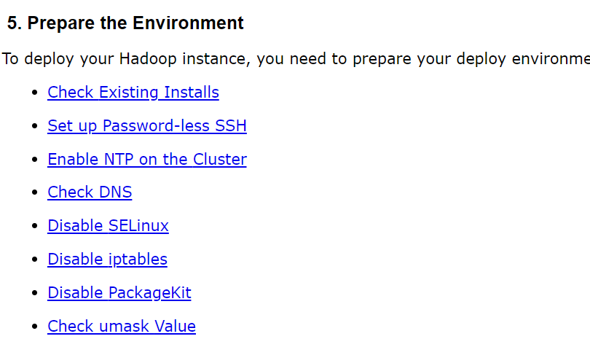

yum install java-1.7.0-openjdk

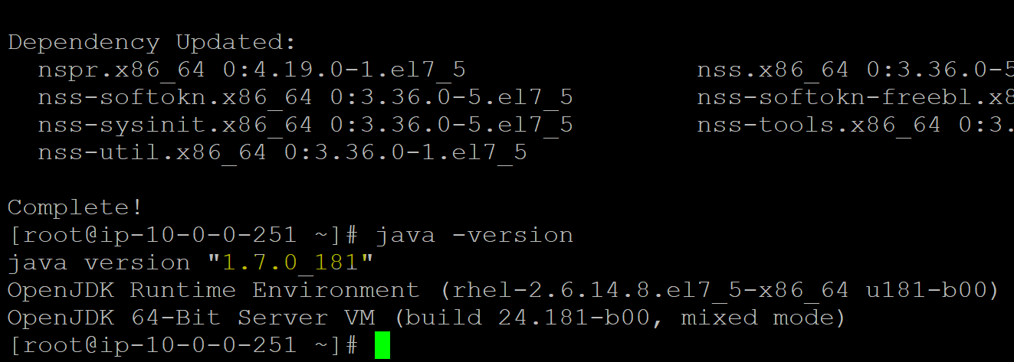

Disable selinux

1. Ensure that in /etc/selinux/config file, “SELINUX=disabled”

Note : Please Repeat above step on all hosts!

setenforce 0

### Disable iptables

chkconfig iptables off

/etc/init.d/iptables stop

You can restart iptables after setup is complete.

yum install httpd -y

chkconfig httpd on

service httpd restart

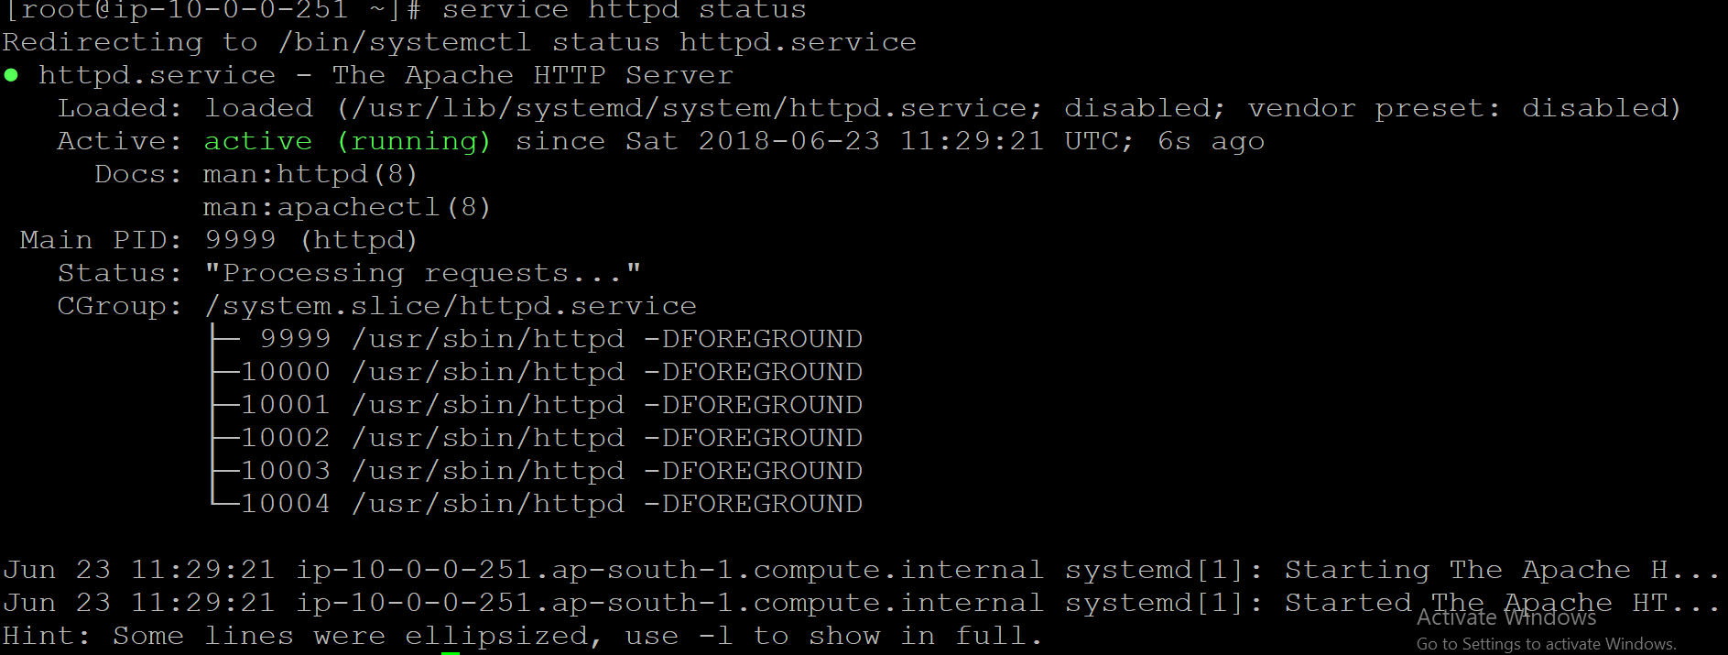

Systemctl –at service

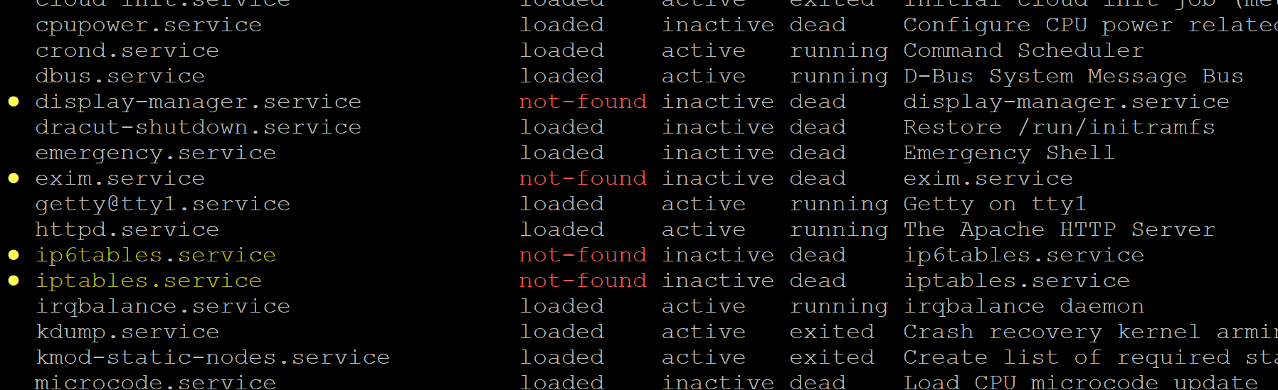

## SETTING UP AMBARI

Get the bits of HDP and add it to the repo:

Steps

1. Log in to your host as root.
2. Download the Ambari repository file to a directory on your installation host.

wget -nv http://public-repo-1.hortonworks.com/ambari/centos7/2.x/updates/2.6.0.0/ambari.repo -O /etc/yum.repos.d/ambari.repo

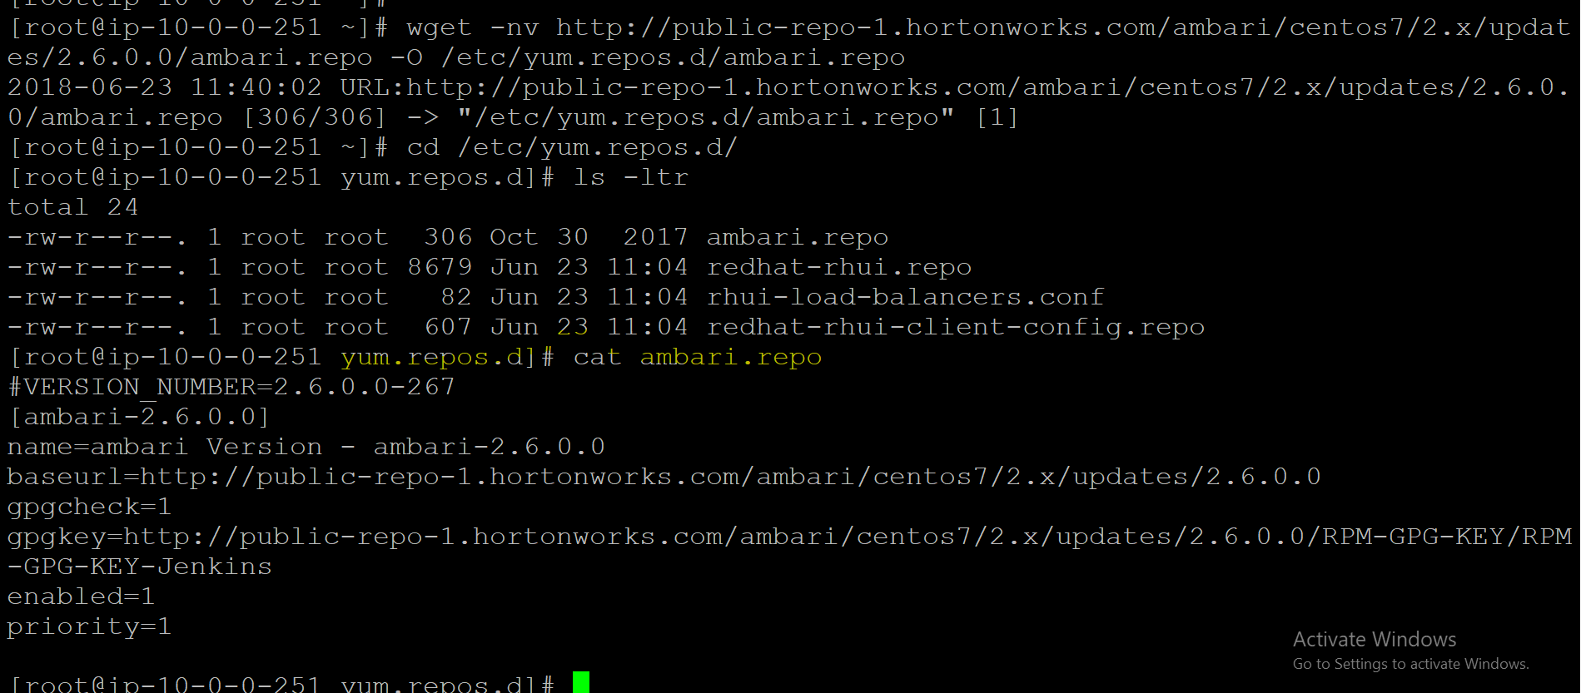

Confirm that the repository is configured by checking the repo list.

yum repolist

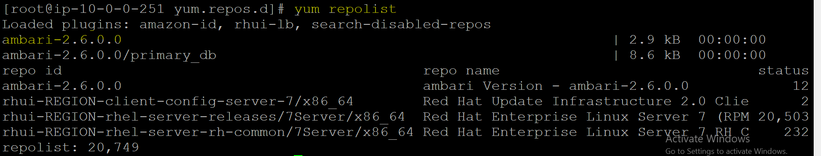

Install the Ambari bits. This also installs the default PostgreSQL Ambari database.

yum install ambari-server

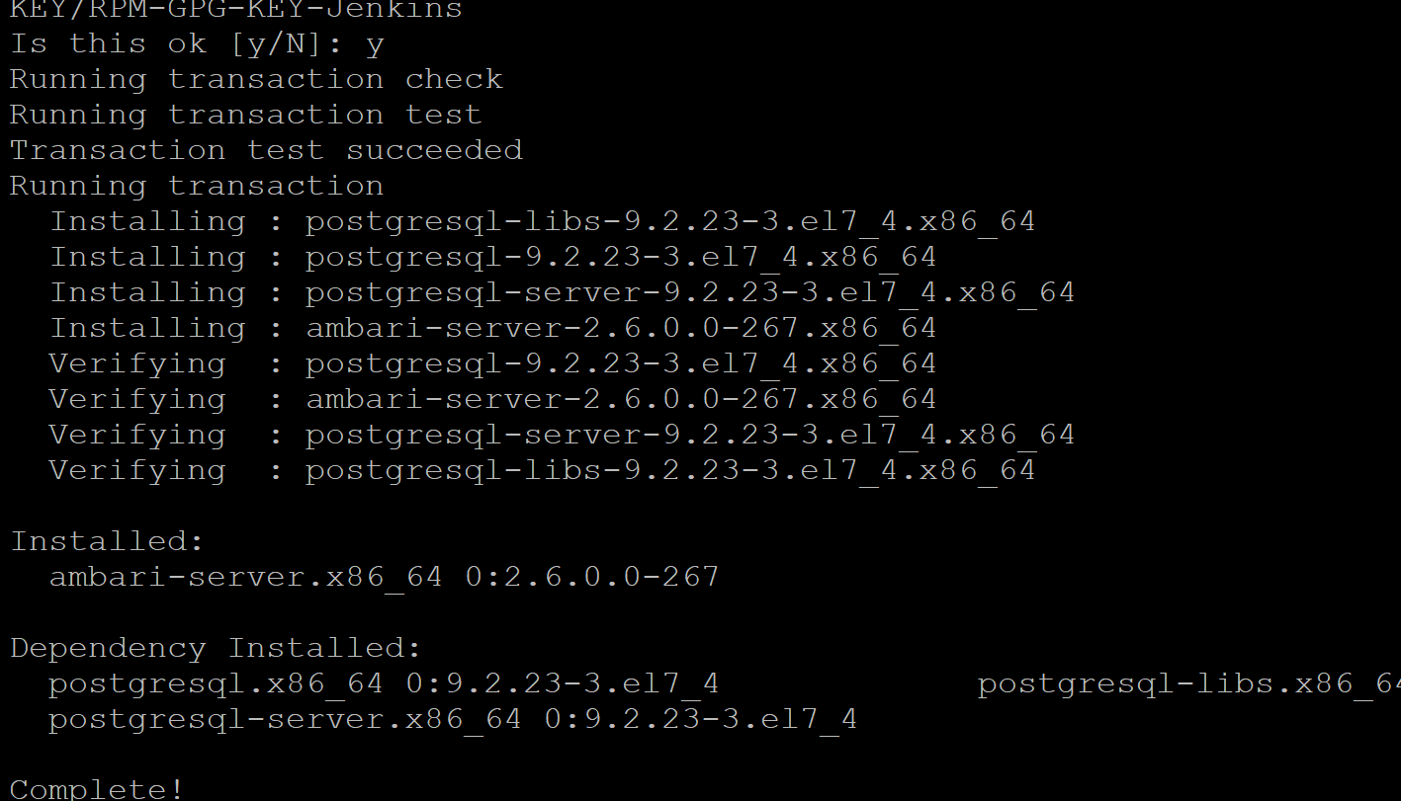

​Set Up the Ambari Server

Before starting the Ambari Server, you must set up the Ambari Server. Setup configures Ambari to talk to the Ambari database, installs the JDK and allows you to customize the user account the Ambari Server daemon will run as. The

ambari-server setup

command manages the setup process. Run the following command on the Ambari server host to start the setup process. You may also append Setup Options to the command.

ambari-server setup

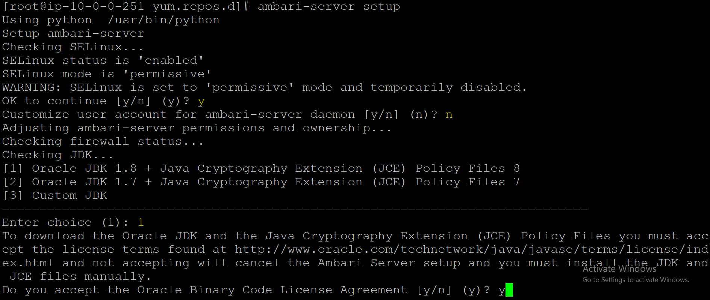

Select n at Enter advanced database configuration to use the default, embedded PostgreSQL database for Ambari. The default PostgreSQL database name is ambari. The default user name and password are ambari/bigdata. Otherwise, to use an existing PostgreSQL, MySQL/MariaDB or Oracle database with Ambari, select y.

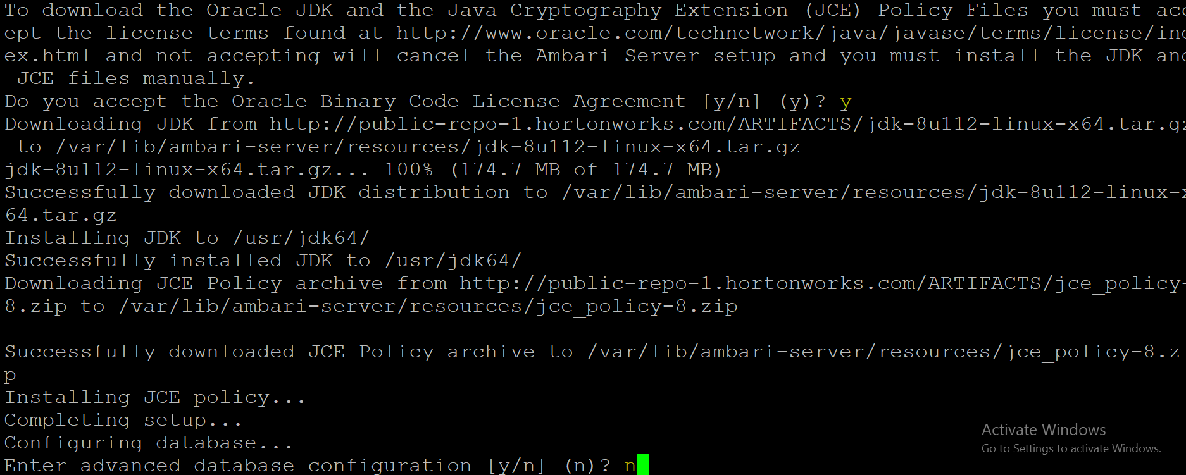

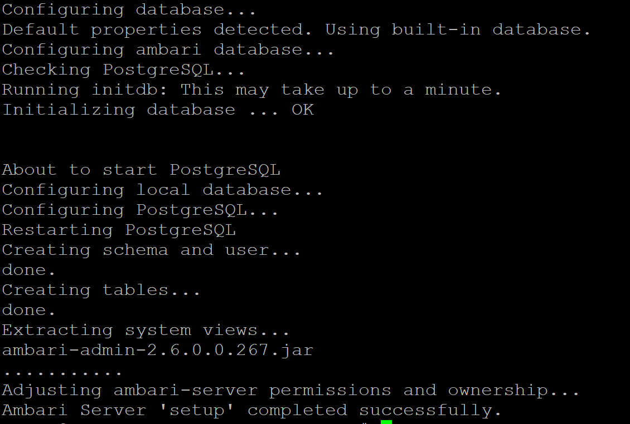

Start Ambari server:

ambari-server status

ambari-server start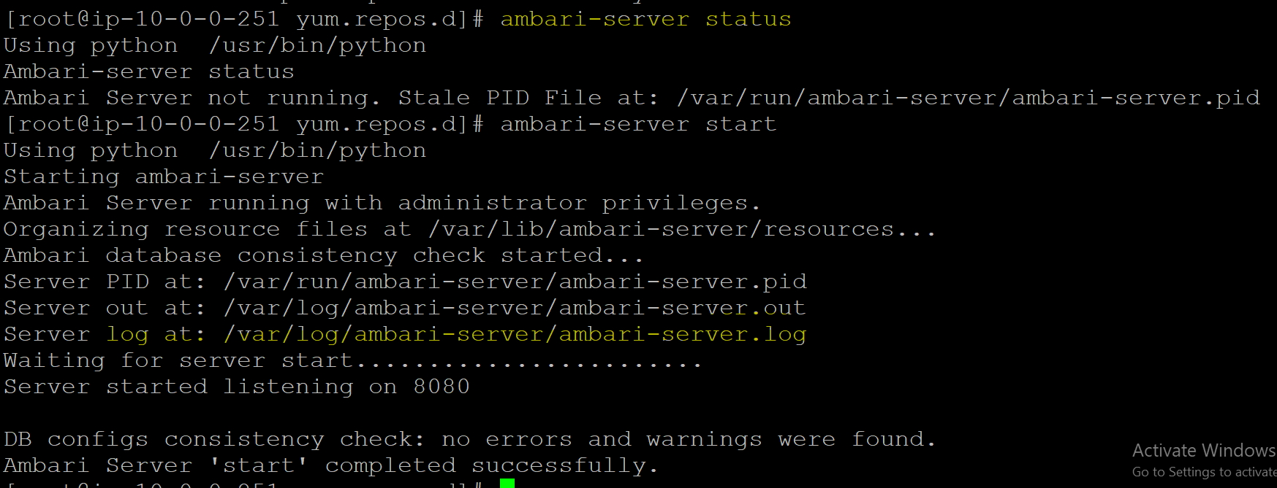

That’s it we are all set to use Ambari to bring up the cluster.

## STEP 4: USING AMBARI TO DEPLOY THE CLUSTER

Copy the public DNS name of the Ambari:

Navigate to port 8080 of the public DNS from your browser. You should see the login page of Ambari. The default username and password is ‘admin’ and ‘admin’ respectively:

Th

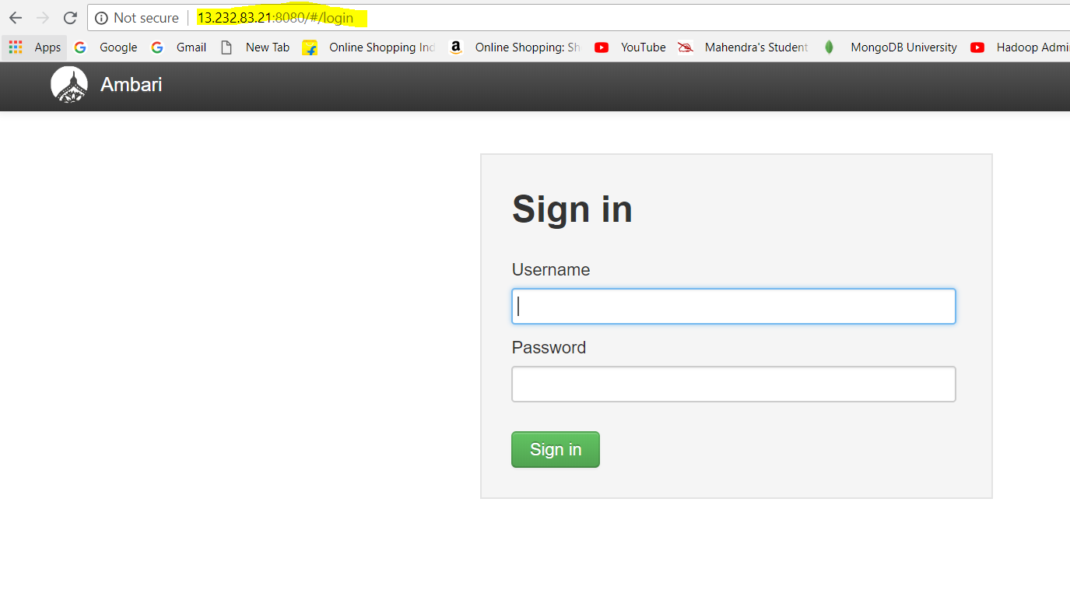

Three instances:

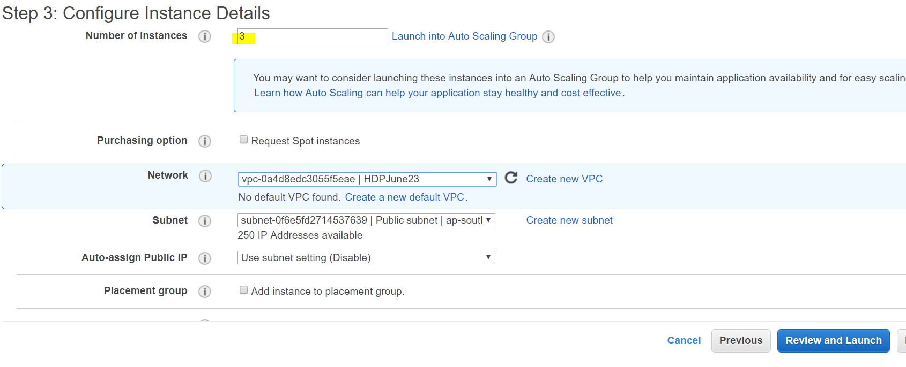

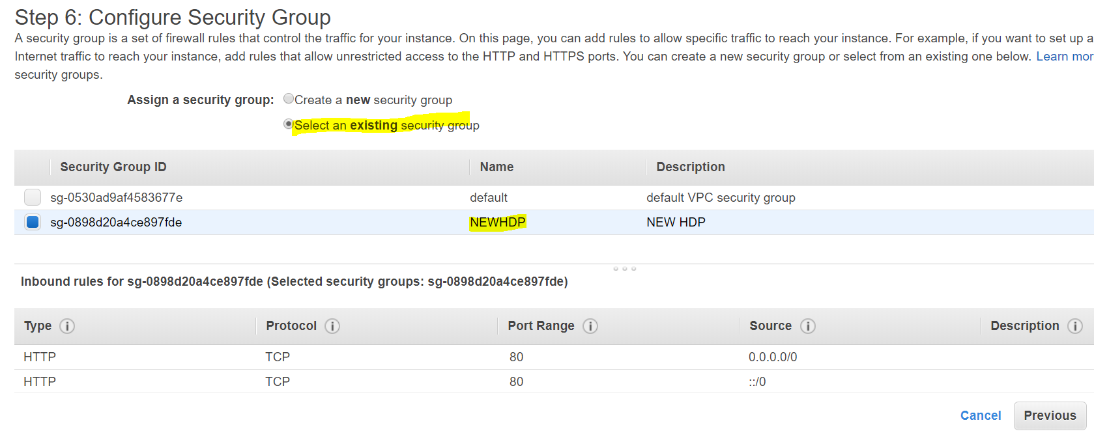

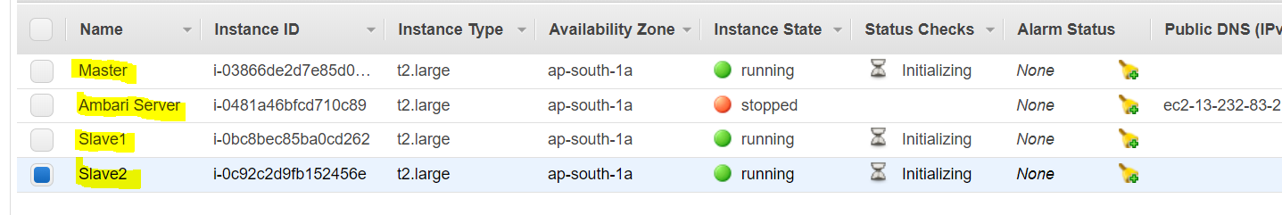

Allocating ip addresses to all 3 nodes

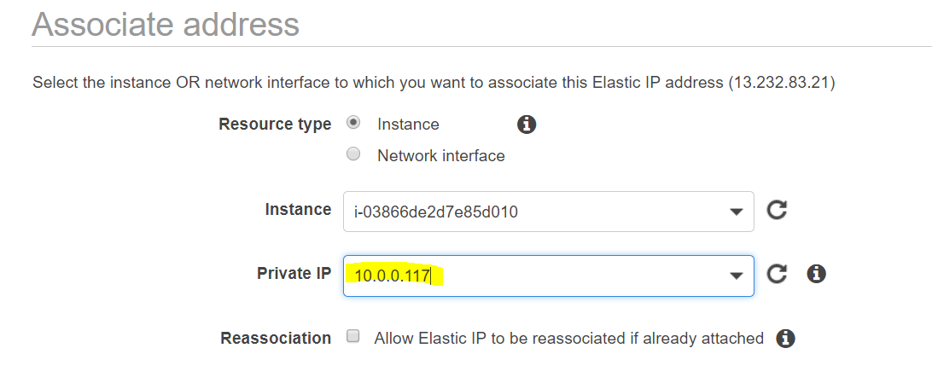

Vi /etc/hosts

ip-10-0-0-251.ap-south-1.compute.internal 10.0.0.251 Ambserver

ip-10-0-0-117.ap-south-1.compute.internal 10.0.0.117 Master

ip-10-0-0-130.ap-south-1.compute.internal 10.0.0.130 Slave1

ip-10-0-0-249.ap-south-1.compute.internal 10.0.0.249 Slave2

Do all pre-requisites on all 3 nodes and restart

## Installing, Configuring, and Deploying a Cluster

Use the Ambari Cluster Install Wizard running in your browser to install, configure, and deploy your cluster, as follows:

* [Start the Ambari Server](https://docs.hortonworks.com/HDPDocuments/Ambari-2.6.2.0/bk_ambari-installation/content/hdp_start_the_ambari_server.html)
* [Log In to Apache Ambari](https://docs.hortonworks.com/HDPDocuments/Ambari-2.6.2.0/bk_ambari-installation/content/log_in_to_apache_ambari.html)
* [Launch the Ambari Cluster Install Wizard](https://docs.hortonworks.com/HDPDocuments/Ambari-2.6.2.0/bk_ambari-installation/content/launching_the_ambari_install_wizard.html)
* [Name Your Cluster](https://docs.hortonworks.com/HDPDocuments/Ambari-2.6.2.0/bk_ambari-installation/content/name_your_cluster.html)
* [Select Version](https://docs.hortonworks.com/HDPDocuments/Ambari-2.6.2.0/bk_ambari-installation/content/select_version.html)
* [Install Options](https://docs.hortonworks.com/HDPDocuments/Ambari-2.6.2.0/bk_ambari-installation/content/install_options.html)
* [Confirm Hosts](https://docs.hortonworks.com/HDPDocuments/Ambari-2.6.2.0/bk_ambari-installation/content/confirm_hosts.html)
* [Choose Services](https://docs.hortonworks.com/HDPDocuments/Ambari-2.6.2.0/bk_ambari-installation/content/choose_services.html)
* [Assign Masters](https://docs.hortonworks.com/HDPDocuments/Ambari-2.6.2.0/bk_ambari-installation/content/assign_masters.html)
* [Assign Slaves and Clients](https://docs.hortonworks.com/HDPDocuments/Ambari-2.6.2.0/bk_ambari-installation/content/assign_slaves_and_clients.html)
* [Customize Services](https://docs.hortonworks.com/HDPDocuments/Ambari-2.6.2.0/bk_ambari-installation/content/customize_services.html)
* [Review](https://docs.hortonworks.com/HDPDocuments/Ambari-2.6.2.0/bk_ambari-installation/content/review.html)
* [Install, Start and Test](https://docs.hortonworks.com/HDPDocuments/Ambari-2.6.2.0/bk_ambari-installation/content/install_start_and_test.html)
* [Complete](https://docs.hortonworks.com/HDPDocuments/Ambari-2.6.2.0/bk_ambari-installation/content/complete.html)

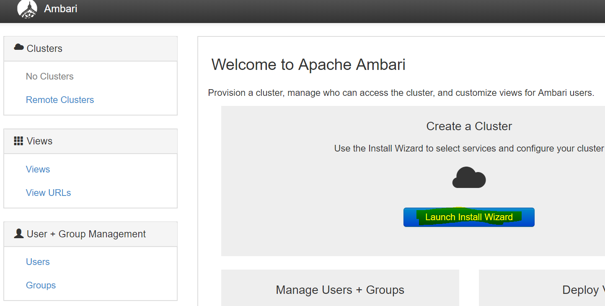

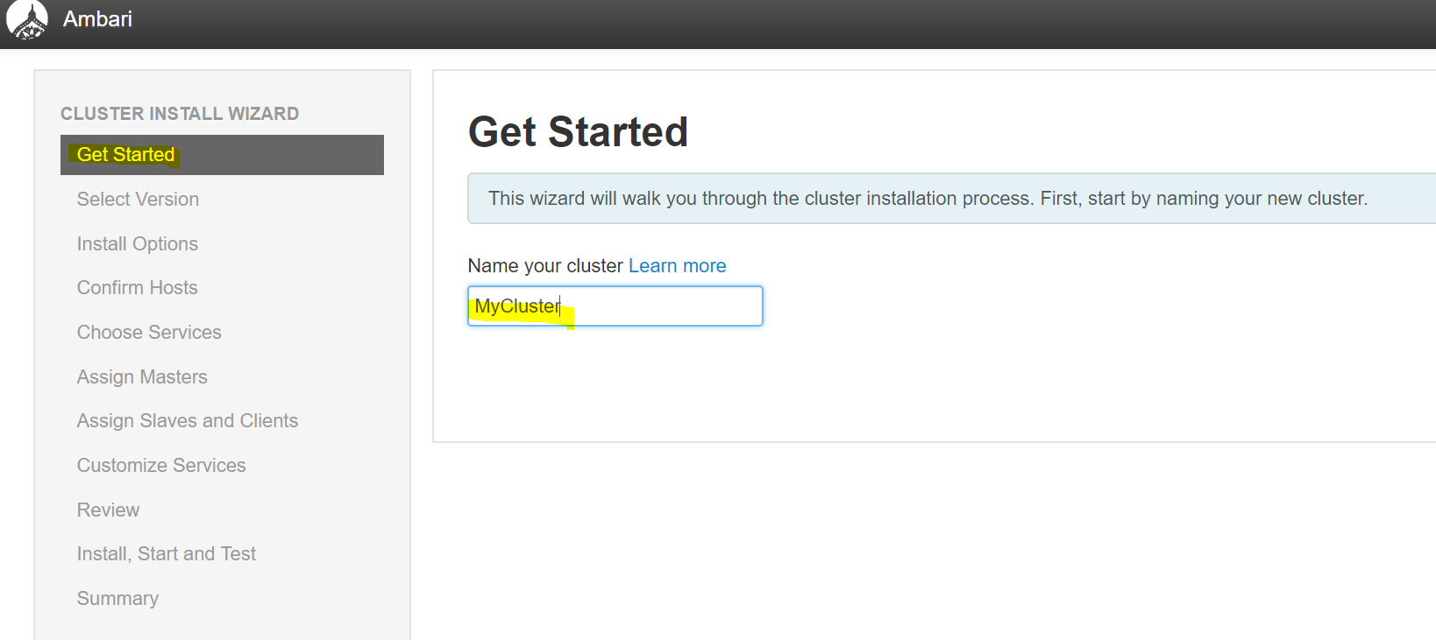

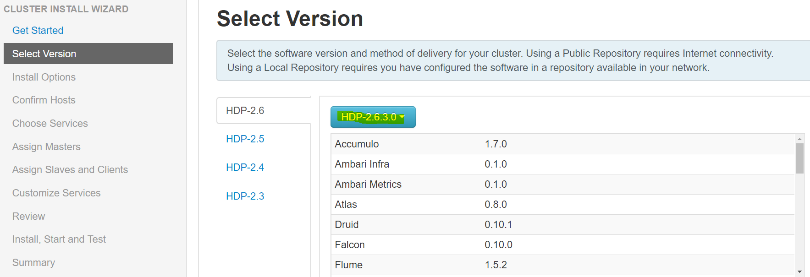

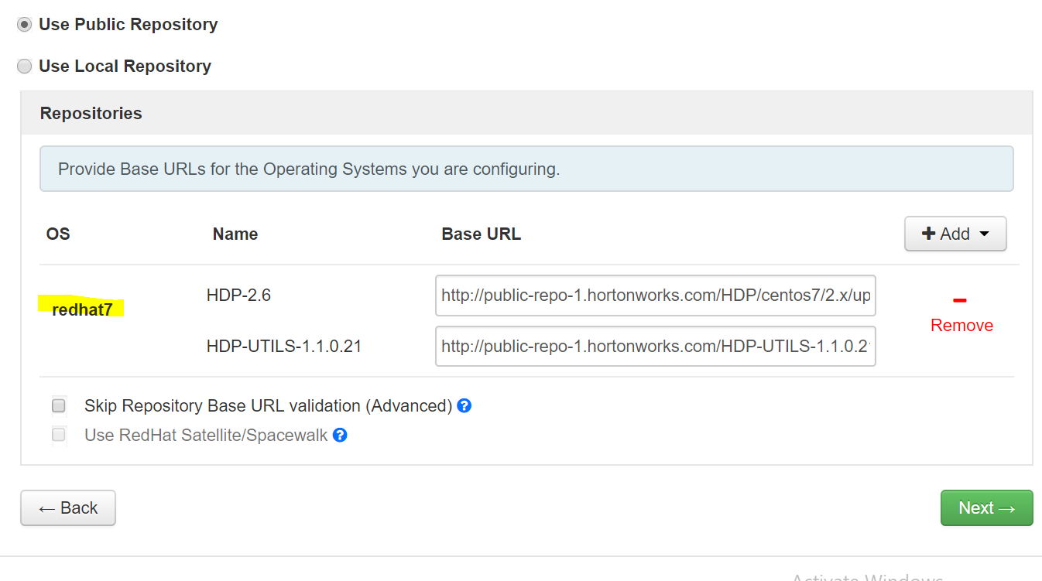

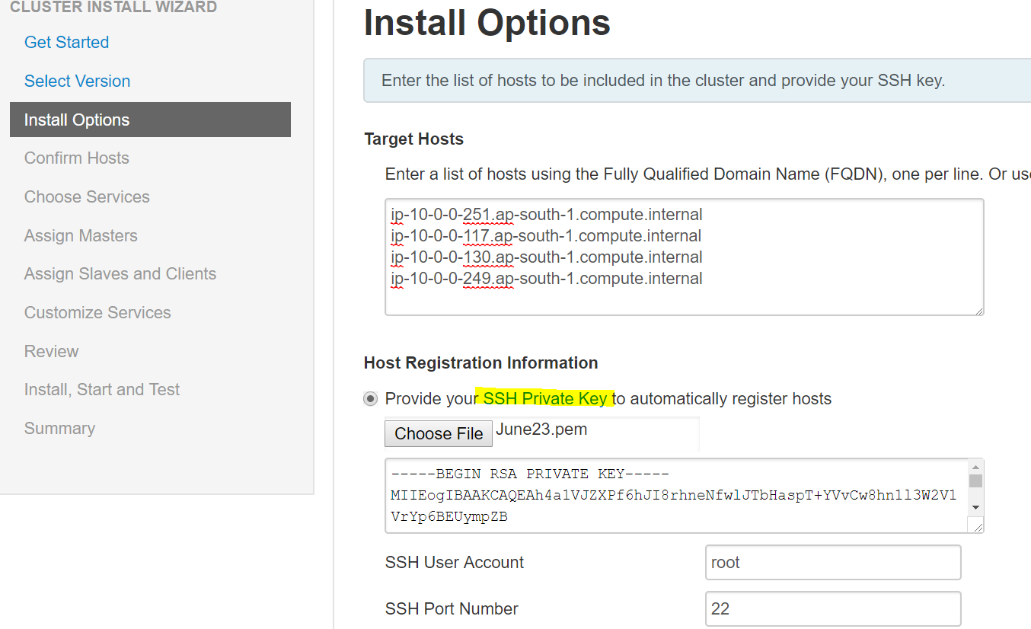

User: ec2-user

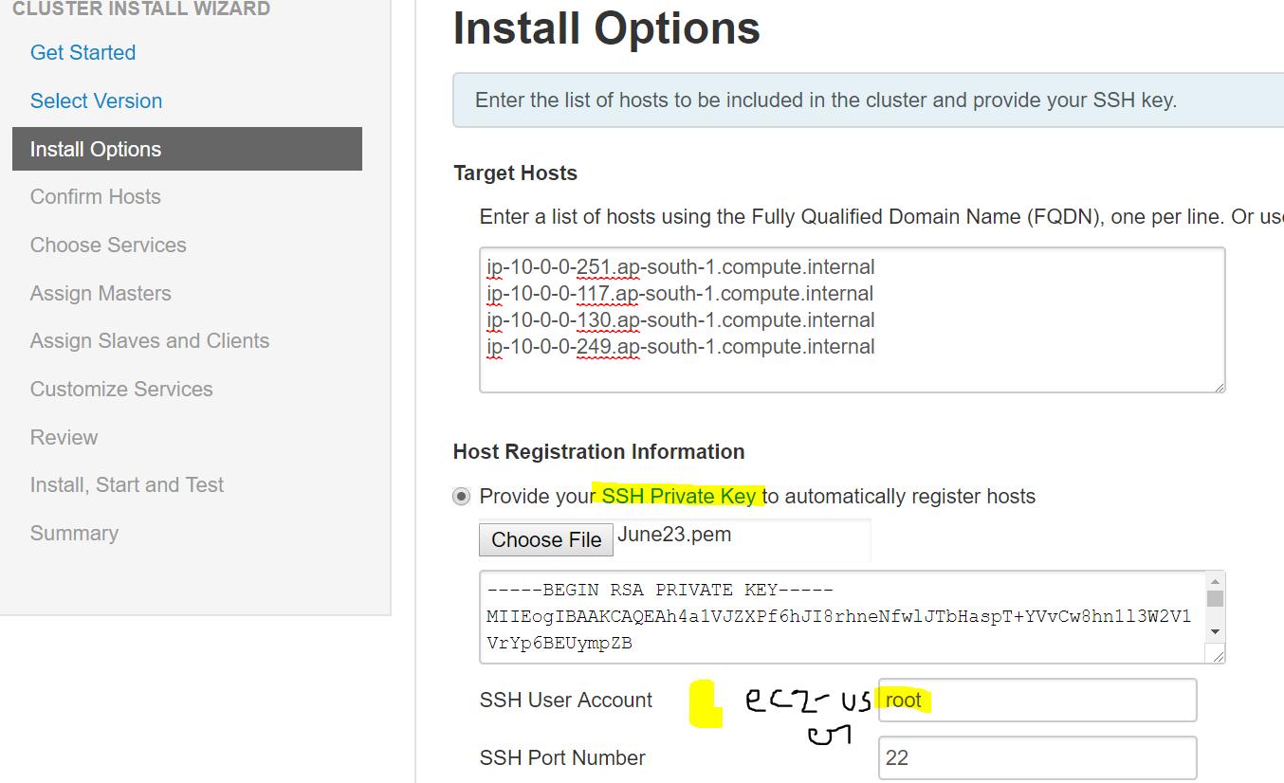

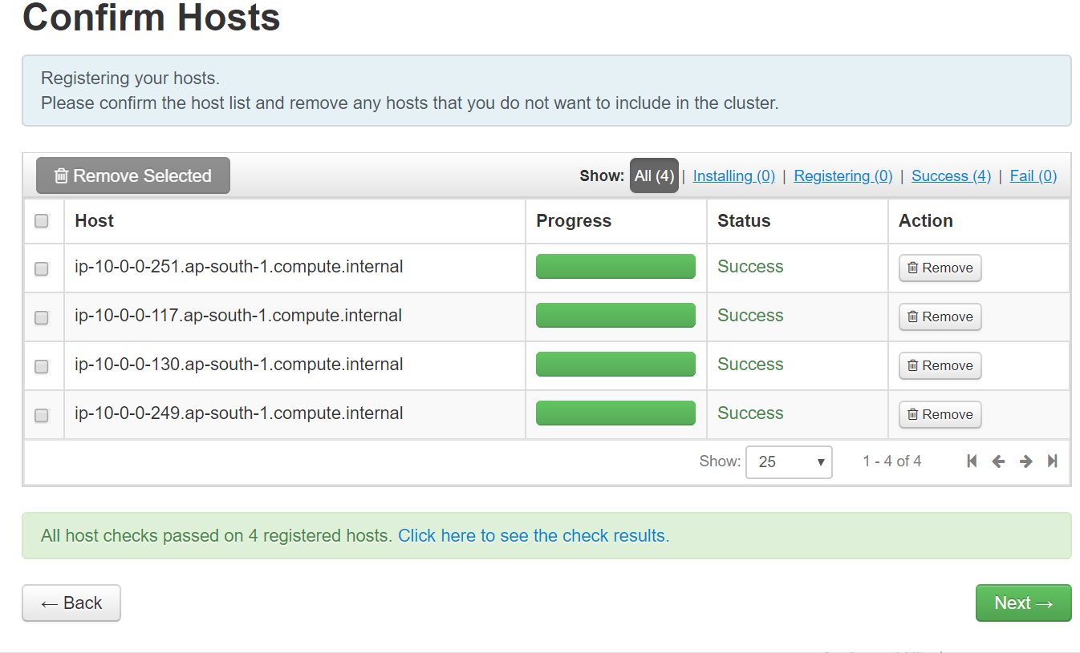

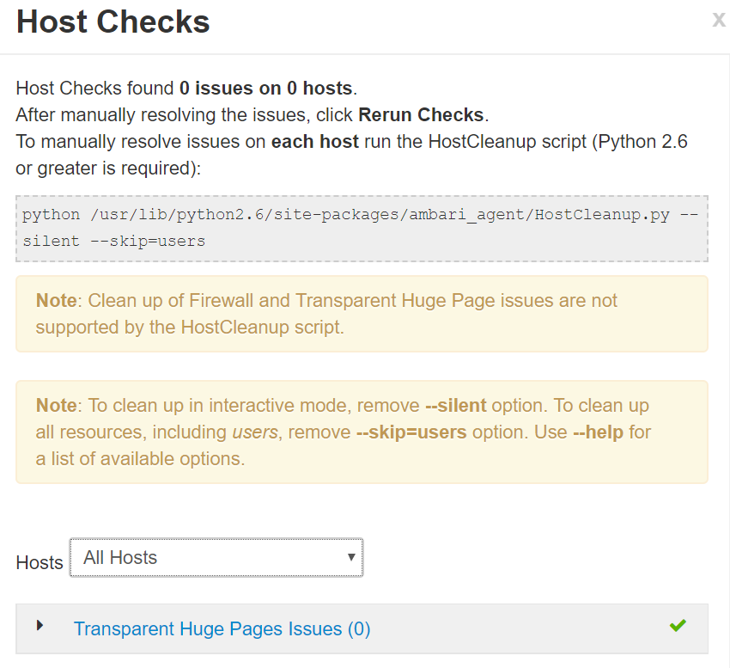

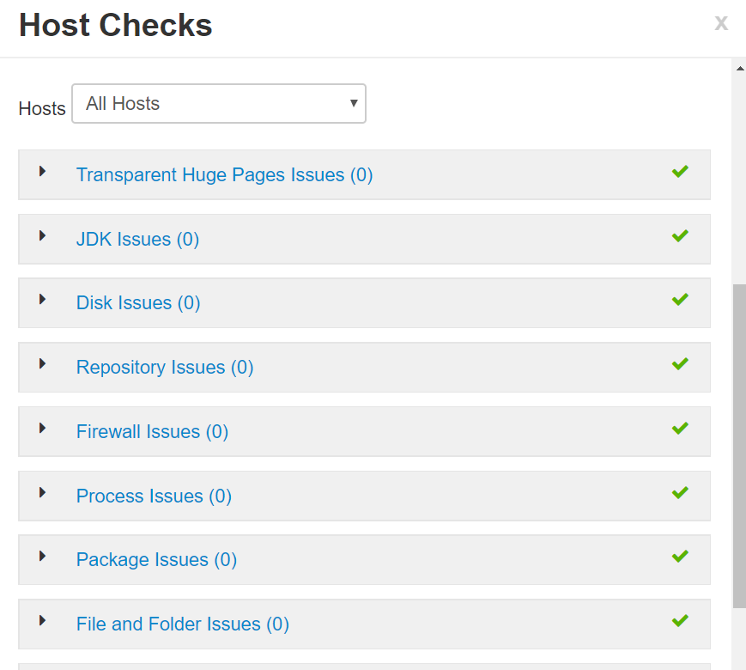

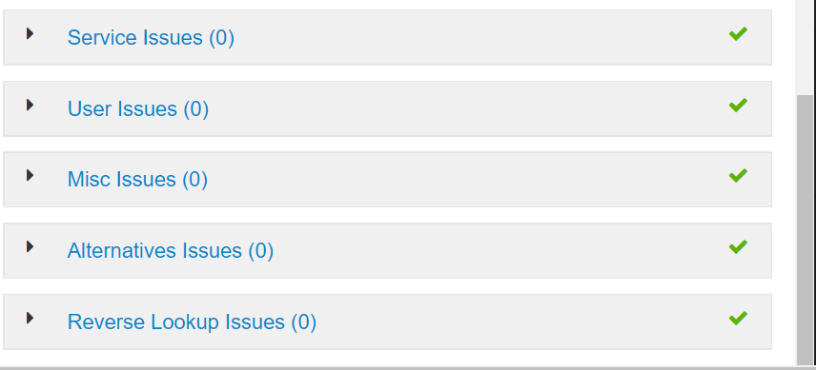

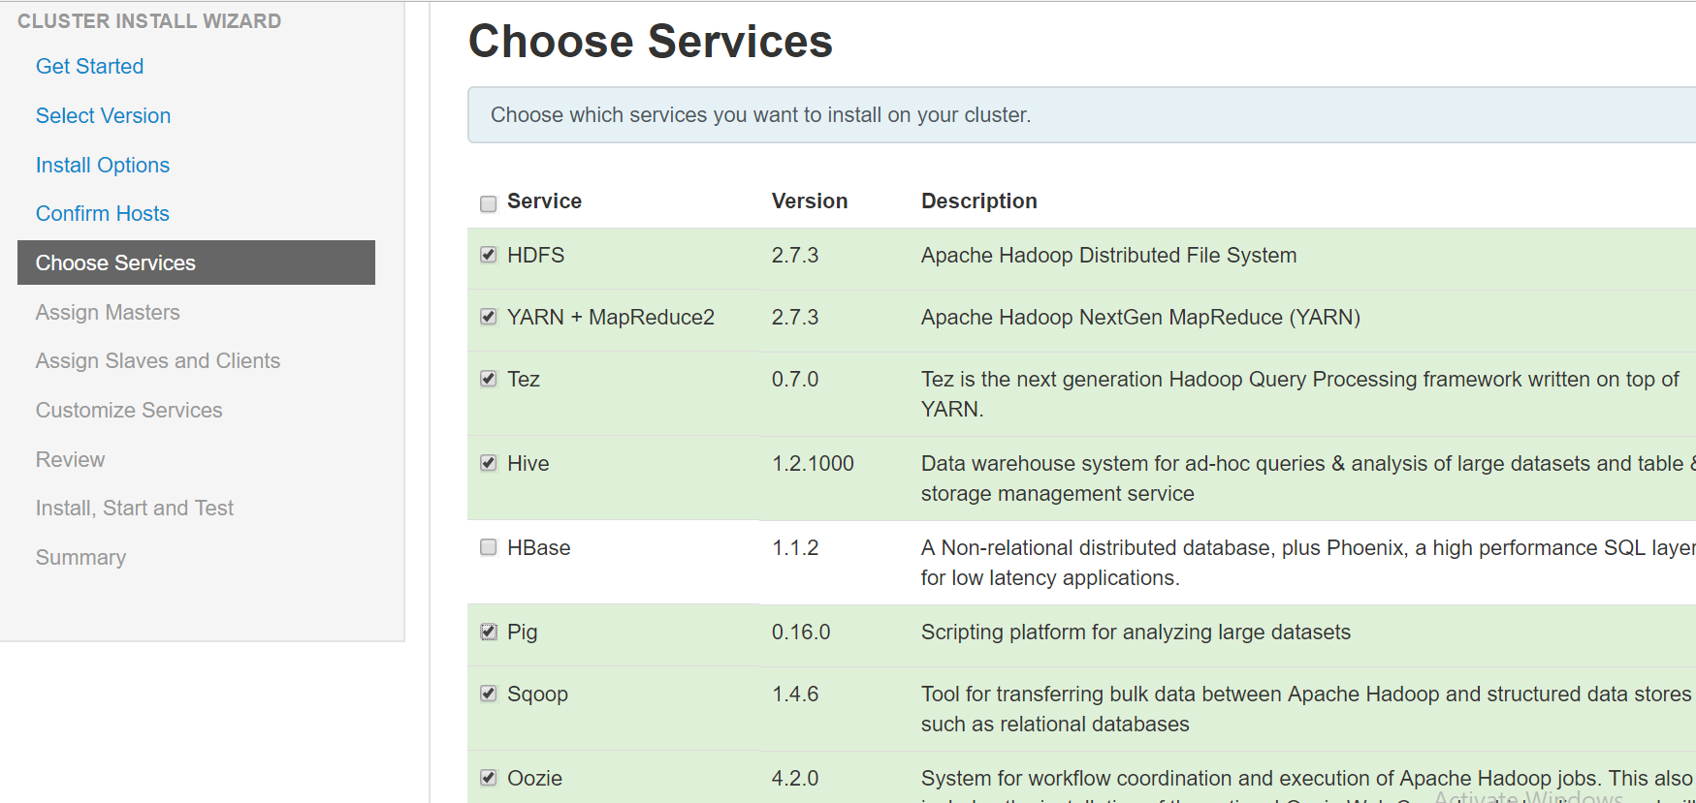

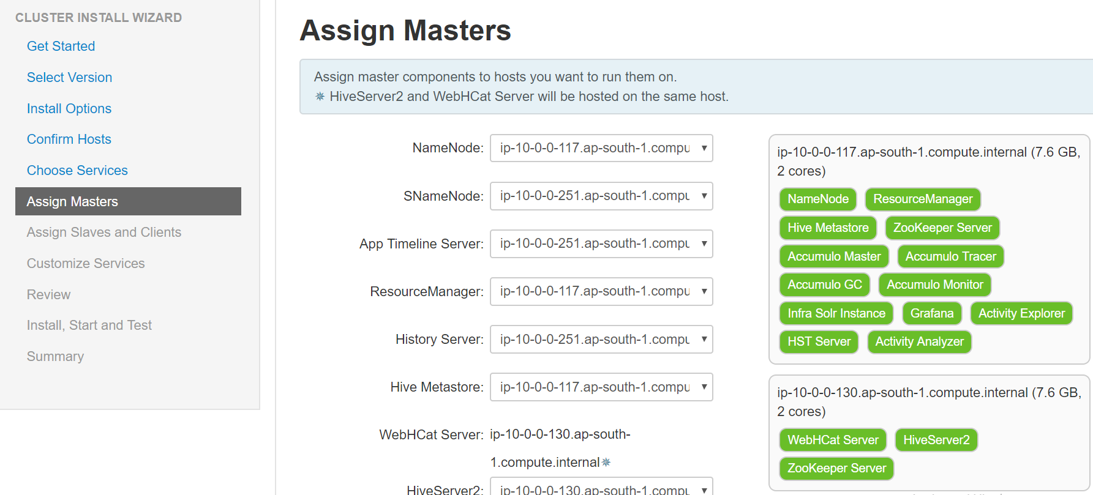

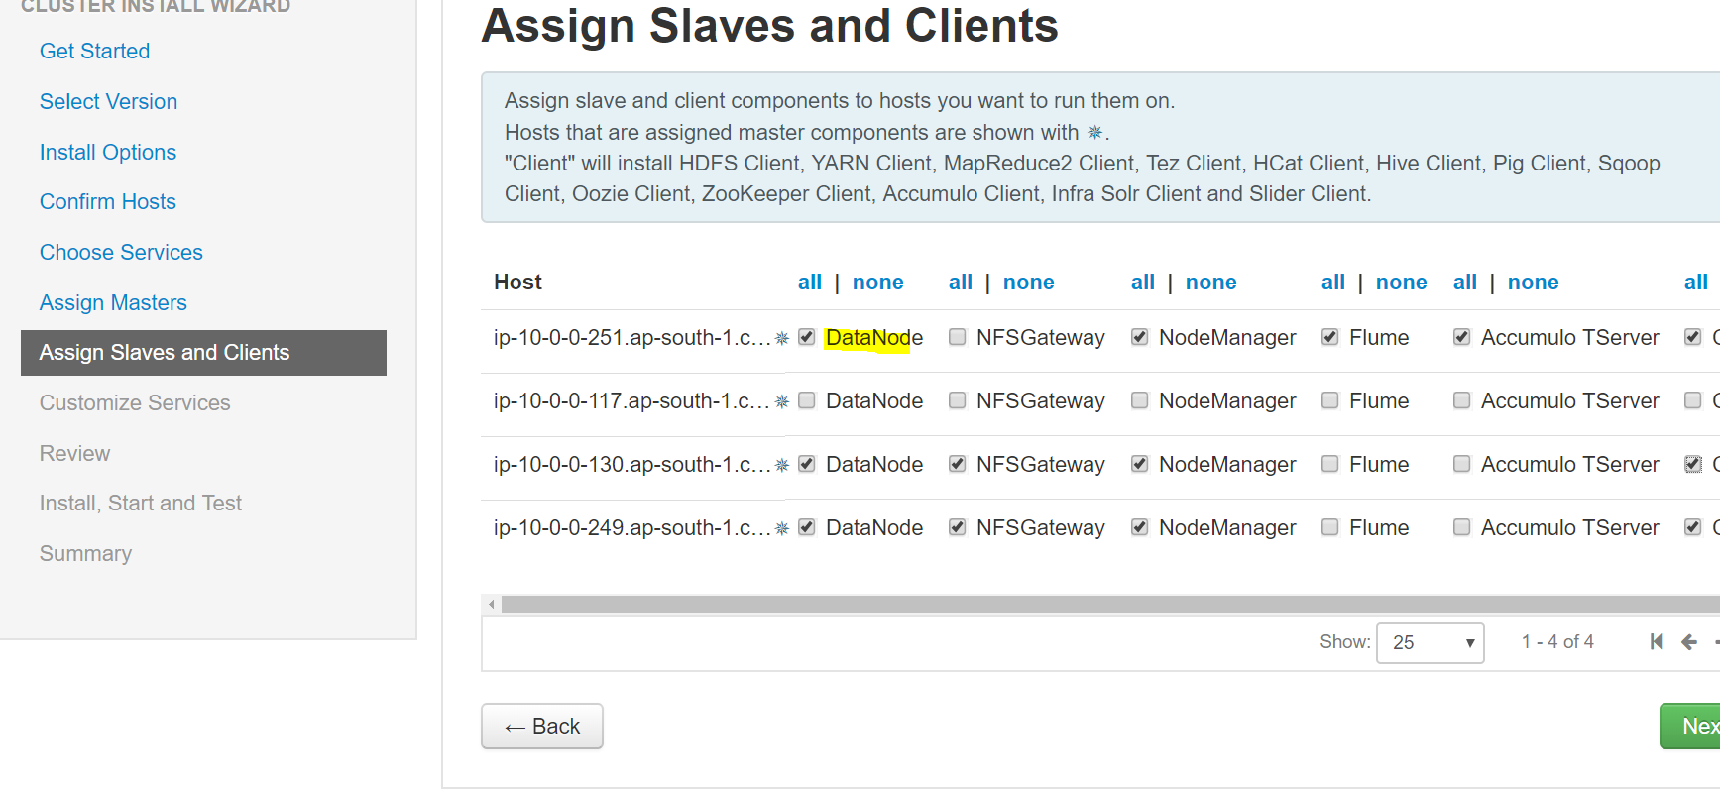

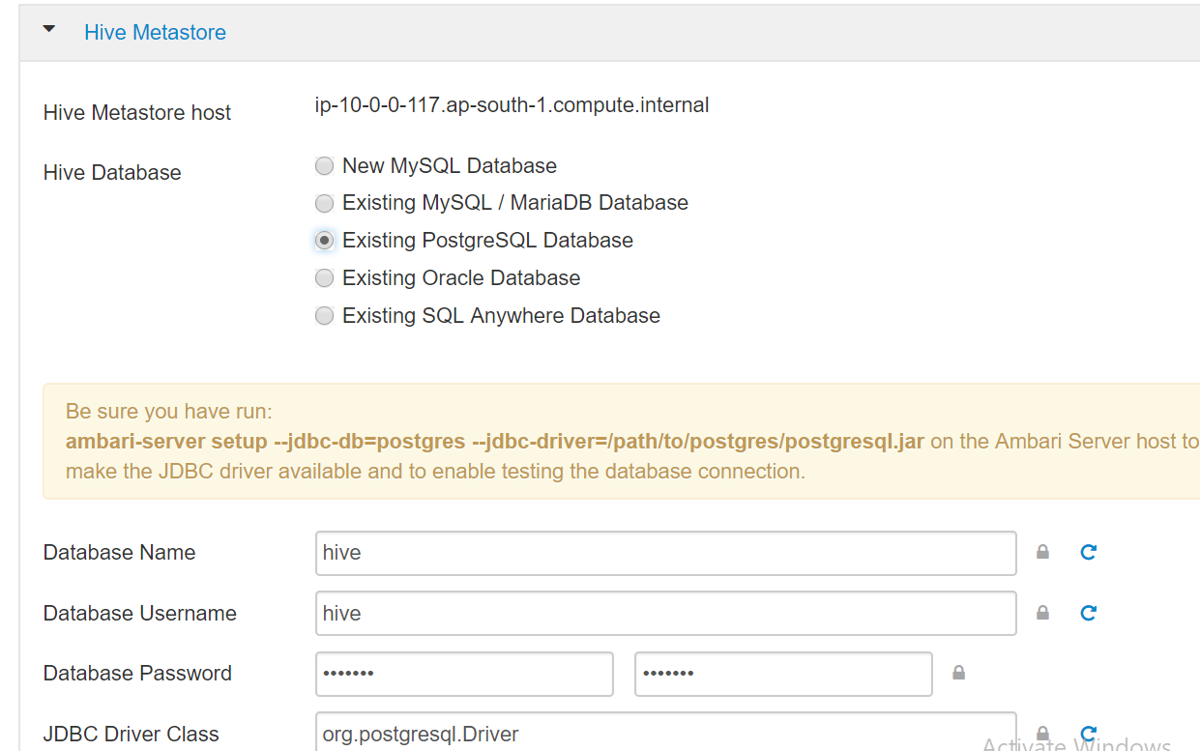

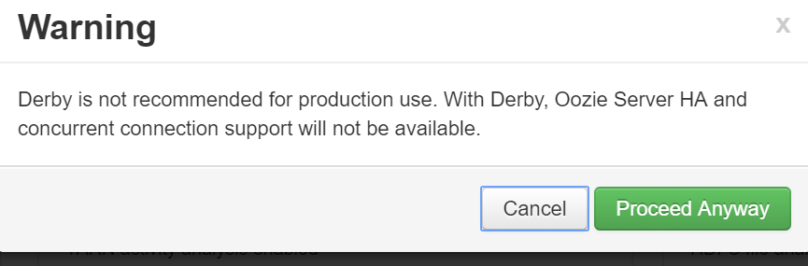

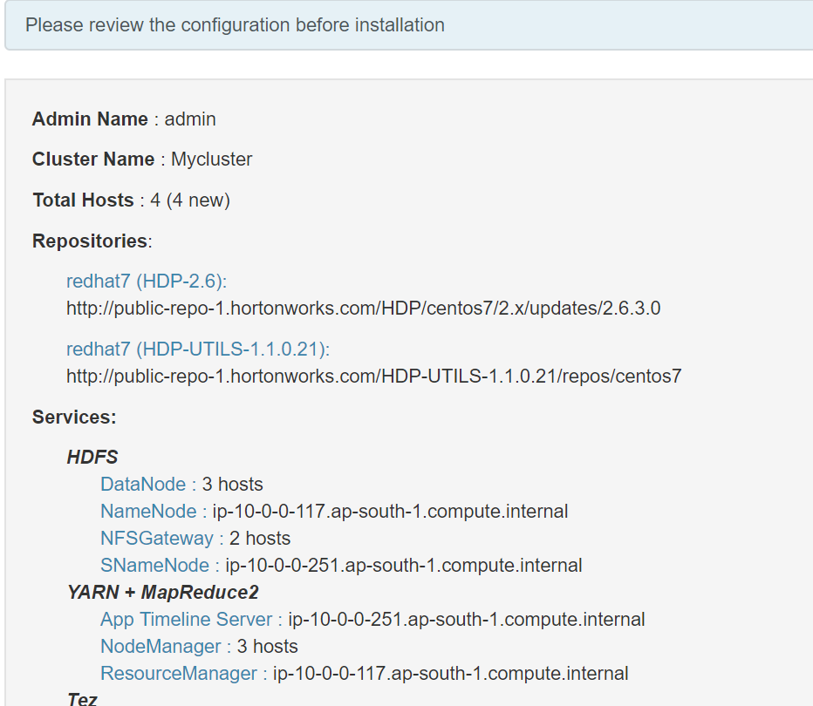

Deploy:

Preparing to deploy 60 tasks

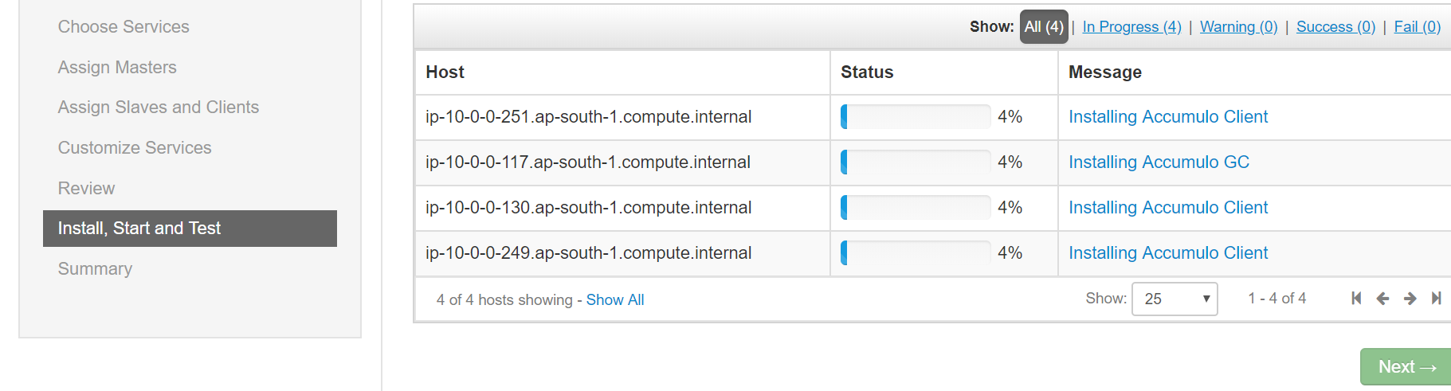

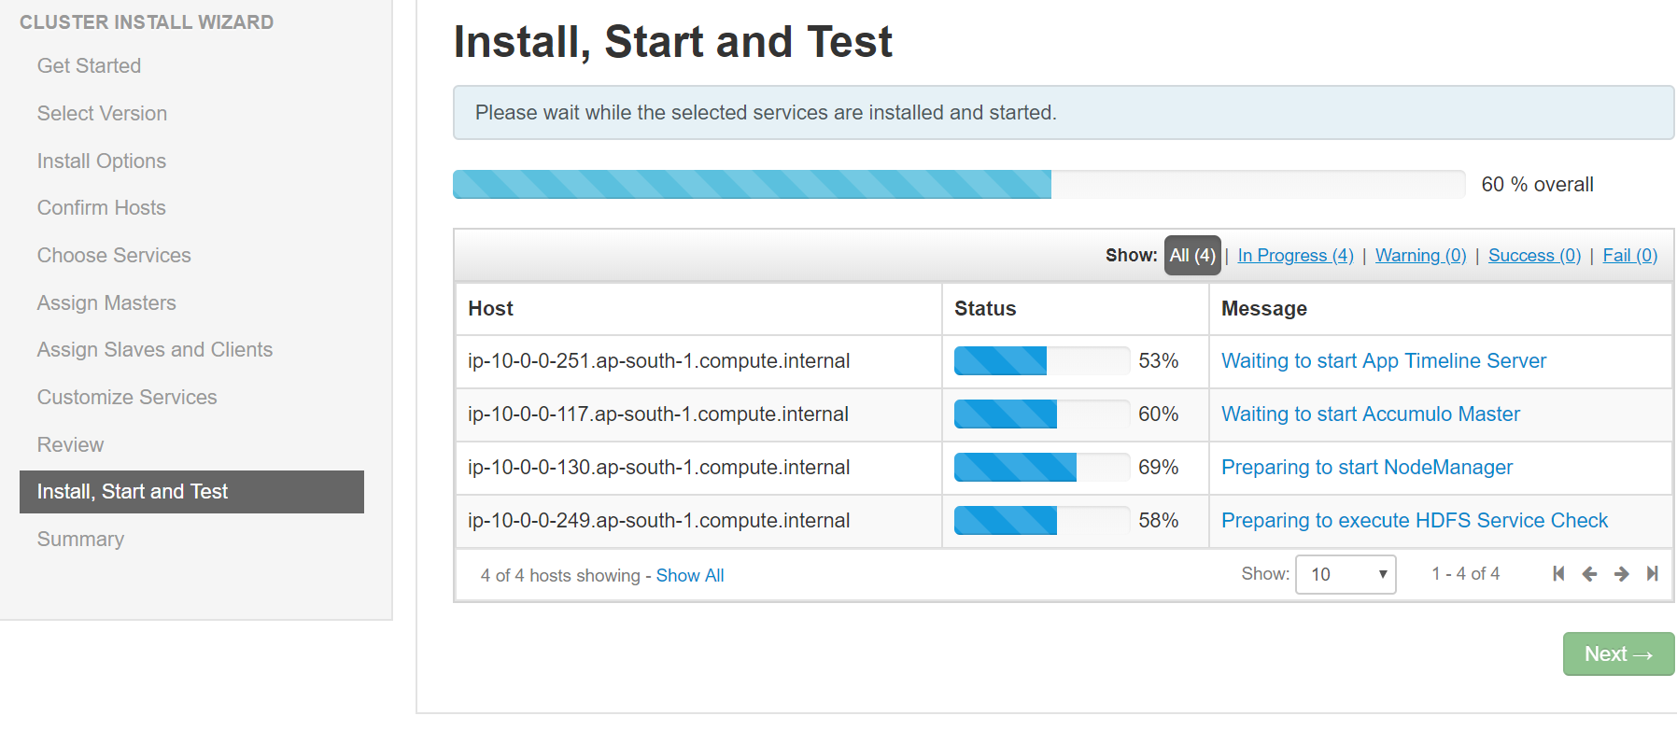

accumulo failing:

yum-config-manager --enable rhui-REGION-rhel-server-optional

sudo yum install libtirpc-devel`````````````````````````````````````````````````````

